Skill-1
Encapsulation Builder
Step 1 to 3:
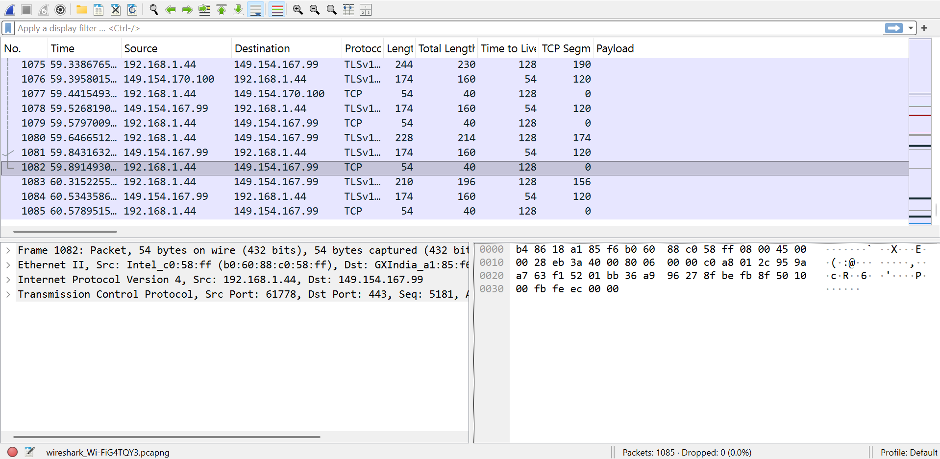
Step 4: tcp
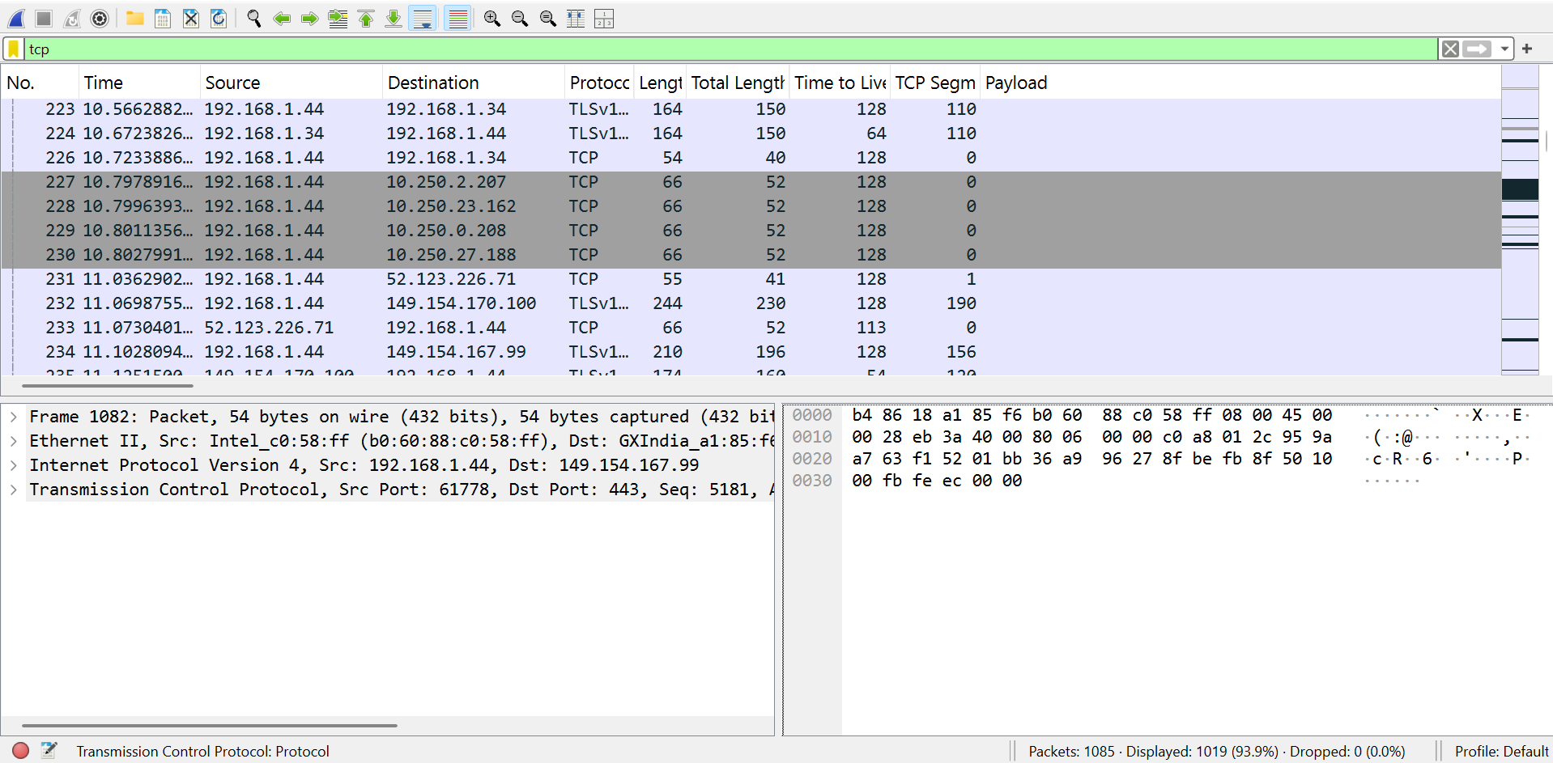
Udp
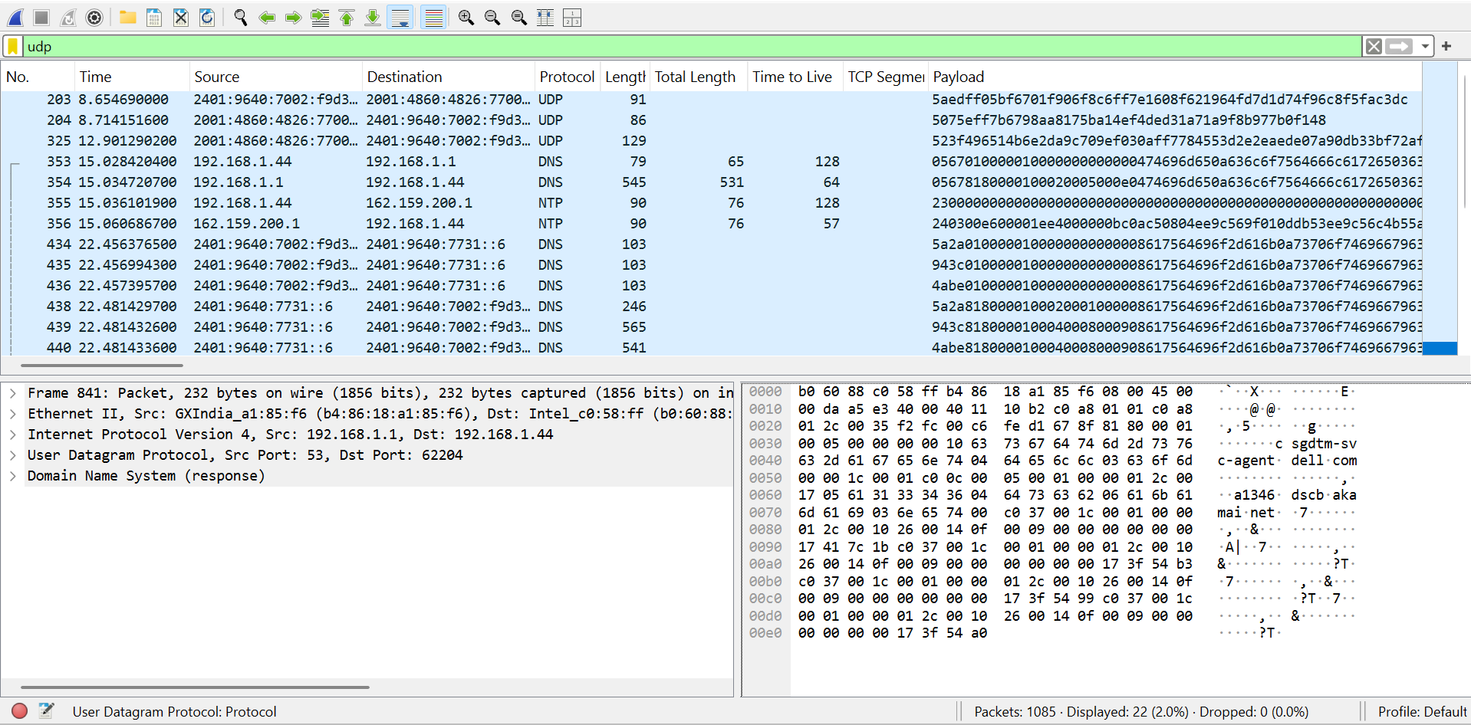
Icmp
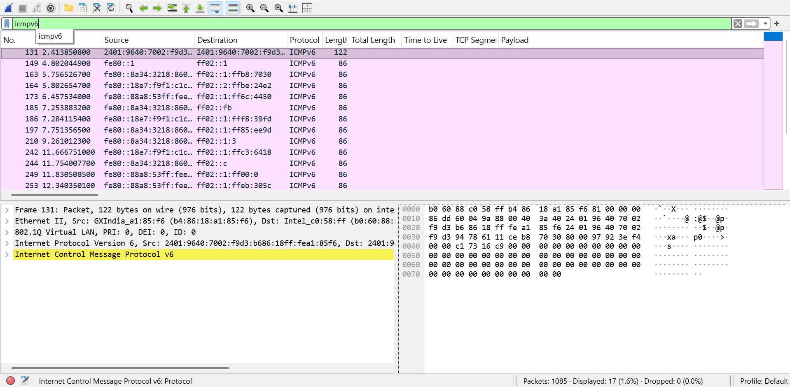
tcp.len > 0 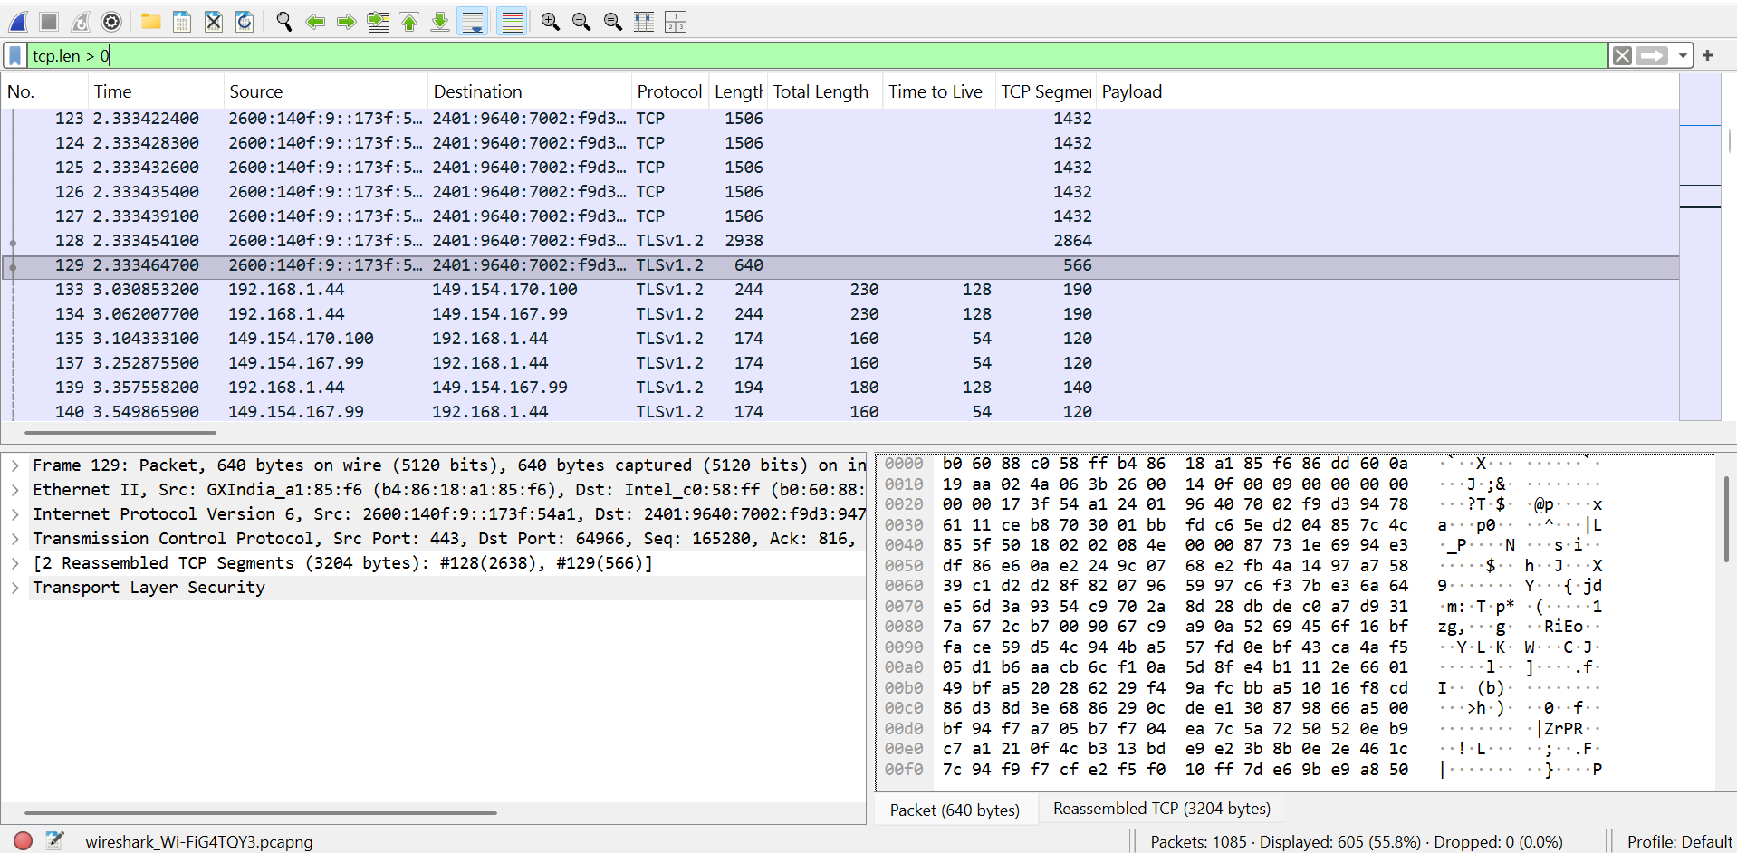

Step 5: Inspect packet headers
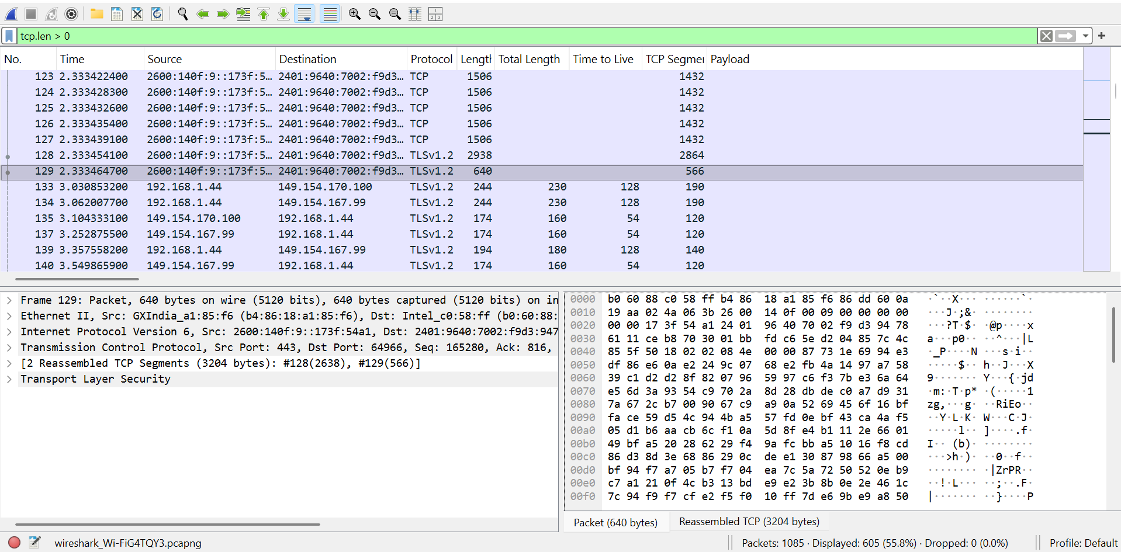
Parameter | Value | Where to find it
Frame length | 244 bytes | Frame section, first line
Ethernet header | 14 bytes | Ethernet II
Source MAC | read from screen | Ethernet II, “Src:”
Destination MAC | read from screen | Ethernet II, “Dst:”
IPv4 header length | 20 bytes | Internet Protocol Version 4
IPv4 total length | 230 bytes | Internet Protocol Version 4
TCP header length | 20 bytes | Transmission Control Protocol
TCP segment length | 190 bytes | “TCP Segment Len”

Step 6: Calculate header overhead
Part 1: Standard example (from the lab)
Ethernet header = 14 bytes
IPv4 header = 20 bytes
TCP header = 20 bytes
Application data = 1500 bytes
FCS = 4 bytes
Total size = 14 + 20 + 20 + 1500 + 4 = 1558 bytes
Total overhead = 14 + 20 + 20 + 4 = 58 bytes
Payload efficiency = (1500 / 1558) × 100 = 96.28%
Part 2: Your captured packet (packet 133)
Ethernet header = 14 bytes
IPv4 header = 20 bytes
TCP header = 20 bytes
Payload (TCP segment length) = 190 bytes
Frame length = 244 bytes
Check: 14 + 20 + 20 + 190 = 244 ✓
Total overhead = 14 + 20 + 20 = 54 bytes (Wireshark doesn’t show the FCS)
Payload efficiency = (190 / 244) × 100 = 77.87%

Step 7: Fill in your observation table
Parameter | TCP Packet (No. 1) | UDP Packet (No. 353)
Frame Length | 210 bytes | 79 bytes
Ethernet Header Length | 14 bytes | 14 bytes
IP Header Length | 20 bytes | 20 bytes
Transport Header Length | 20 bytes | 8 bytes
IP Total Length | 196 bytes | 65 bytes
Transport Segment/Datagram Length | 176 bytes (20 + 156) | 45 bytes (8 + 37)
Payload Length | 156 bytes | 37 bytes

Question and answers
1. What is encapsulation?
Encapsulation is the process where each layer of the network stack adds its own header (and sometimes a trailer) to the data from the layer above before passing it down. Application data becomes a TCP segment or UDP datagram, then an IP packet, then an Ethernet frame. The receiving device reverses this (decapsulation), removing one header at each layer.
2. What is the purpose of the Ethernet header?
The Ethernet header (14 bytes) handles delivery within a local network. It contains the destination MAC address (6 bytes), the source MAC address (6 bytes), and the EtherType (2 bytes), which says which protocol is inside, such as IPv4 or IPv6. In your capture, the source MAC is your laptop (b0:60:88:c0:58:ff) and the destination is your router (b4:86:18:a1:85:f6).
3. What information is stored in the IP header?
The IPv4 header (usually 20 bytes) holds the version, header length, total length, identification, flags and fragment offset, time to live (TTL), protocol number (6 for TCP, 17 for UDP), header checksum, and the source and destination IP addresses. It handles routing across networks. In your capture, the IP addresses are 192.168.1.44 and 149.154.167.99.
4. What is the difference between TCP and UDP headers?
 | TCP | UDP
Header size | 20 bytes minimum (more with options) | 8 bytes fixed
Fields | Source/destination ports, sequence number, acknowledgment number, flags, window size, checksum | Source/destination ports, length, checksum
Connection | Connection-oriented | Connectionless
Reliability | Reliable, with acknowledgments, retransmission, and ordering | Unreliable, with no guarantees
Speed | Slower because of overhead | Faster and lighter
Examples | HTTPS, email, file transfer | DNS, streaming, gaming
5. Why does each protocol add a header?
Each layer has its own job, and it needs control information to do it. The transport layer needs ports to deliver data to the right application, plus sequencing and reliability information. The network layer needs IP addresses to route packets between networks. The data link layer needs MAC addresses to deliver frames on the local link. Headers let each layer work independently and let the receiving side know how to process the data.
6. What is packet overhead?
Packet overhead is the extra bytes in a packet that are not application data, namely the protocol headers (and trailer such as the FCS). For an Ethernet + IPv4 + TCP packet, overhead is 14 + 20 + 20 = 54 bytes (58 with the FCS). In your TCP packet, 54 of the 210 bytes were overhead and 156 were payload.
7. How does header overhead affect network efficiency?
Overhead uses bandwidth that could carry useful data. Efficiency is payload ÷ total frame size × 100. Because header size is fixed, small payloads have low efficiency and large payloads have high efficiency. In the lab’s example, a 1500-byte payload gives 96.28%. In your capture, the TCP packet with 156 bytes of payload gives 74.29%, and the UDP packet with only 37 bytes gives 46.84%. So larger packets use the network more efficiently, and tiny packets (like DNS queries or acknowledgments) waste a larger share on headers.
Since these are lab answers your faculty will read, put them in your own phrasing and include your own packet numbers where I’ve used them. Also make sure the packet numbers in your answers match the ones in your Step 5-7 screenshots and table.

